PORTFOLIO PROJECT

Submitted by

**LALITHA P**

**Reg. No: 1P23CS014**

In partial fulfilment of the requirement for the award of the Degree of

**Master of Science in Computer Science**

**Bharathiar University**

**Coimbatore.**

Under the Internal Supervision of

**Dr. P. V. Ravindranath**

**Assistant Professor**

**School of Computer Studies-PG**



**School of Computer Studies-PG**

**Rathnavel Subramaniam College of Arts and Science (Autonomous),**

**Sulur, Coimbatore – 641 402**

**February 2023**

#### RATHNAVEL SUBRAMANIAM COLLEGE OF ARTS AND SCIENCE (AUTONOMOUS)

**AFFILIATED TO BHARATHIAR UNIVERSITY**

**NAAC Re-accredited & ISO 9000:2008 Certified SULUR, COIMBATORE-641402.**



**February 2023**

**Register Number – 1P23CS014**

Certified bona fide original record of work done by **LALITHA P**

#### Internal Supervisor HOD

Submitted for the project Evaluation and Viva voice held on**………………….**

#### Internal Examiner External Examiner

PORTFOLIO PROJECT

**Chapter 1:**

Video Introduction

* 1. YouTube Video

**Chapter 2:**

Website Bio Score

2.1. Minimum 50 words (Include photo)

2.2. Contact Information (LinkedIn, GitHub, Email, Etc.)

**Chapter 3:**

Pages & Navigation

3.1. Landing Page

3.2. Project Page

3.3. Navigation Bar

**Chapter 4:**

Styles Score

4.1. Styles (Font Color Images)

4.2. Styles Link (Link in Blue color & Underline Navigation)

4.3. Use of Grid Layout 4

**Chapter 5:**

Website Include the Following Information

5.1. Project Links to GitHub

5.2. Project Description (1-5 sentences per projects)

**Chapter 6:**

Bootstrap

6.1. Uses Bootstrap

**Chapter 7:**

Project README

7.1. Title Description (Min 20 words)

7.2. How to Run Project

7.3. Future improvements of projects

**Chapter 8:**

File Structure

8.1. GitHub File Structure

PORTFOLIO PROJECT

**CHAPTER 1**

VIDEO INTRODUCTION

* 1. YouTube video Introduction

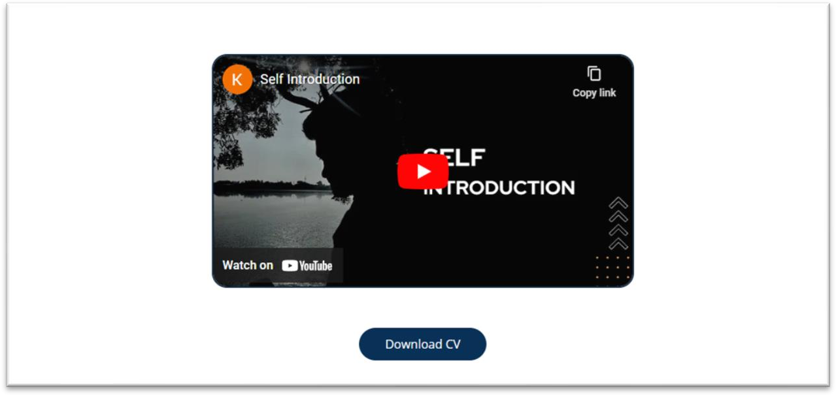

Source code:

HTML

<div class="self"><center><iframe width="560" height="315" src="https://[www.youtube.com/embed/i_ZeRX_TprM"](http://www.youtube.com/embed/i_ZeRX_TprM) class="selfintro" title="YouTube video player" frameborder="0" allow="accelerometer; autoplay; clipboard-write; encrypted-media; gyroscope; picture-in-picture" allowfullscreen></iframe></center></div>

CSS

.selfintro{

*border-radius*: 20px;

*border*: 2px solid #142b47;

*animation*: self 1s ease-in-out;

**CHAPTER 2**

WEBSITE BIO SCORE

2.1 About me

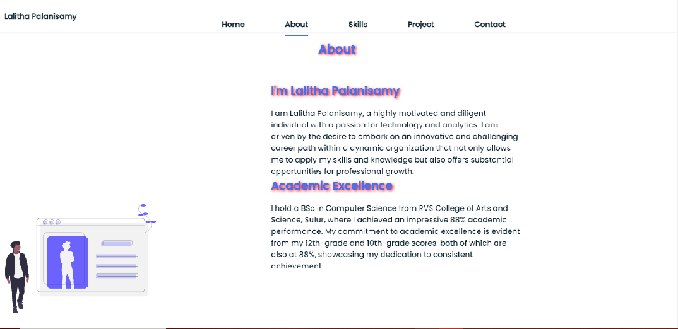

Figure-2.1

Description:

In this page, paragraph about me, academic profile and my achievements. User can know about my Objective, academic profile, passion and achievements.

Source code:

HTML:

 <!--ABOUT SECTION-->

            <section class="about section" id="about">

              <h2 class="section_title" data-aos="fade-down"> About</h2>

                <div class="about_container bd_grid">

                    <div class="about_img" data-aos="fade-down" data-aos-delay="250">

                        <svg id="fe80fb2b-bcaf-407e-919b-306adc32f78b" data-name="Layer 1" xmlns="http://www.w3.org/2000/svg"  viewBox="0 0 1032 741.75278</svg>

                    </div>

                    <div>

                        <h2 class="about_subtitle"  data-aos="fade-down" data-aos-delay="350">I'm Lalitha Palanisamy</h2>

                        <p class="about_text"  data-aos="fade-down" data-aos-delay="450">

                            I am Lalitha Palanisamy, a highly motivated and diligent individual with a passion for technology and analytics. I am driven by the desire to embark on an innovative and challenging career path within a dynamic organization that not only allows me to apply my skills and knowledge but also offers substantial opportunities for professional growth.

                        </p>

                        <h2 class="about_subtitle" data-aos="fade-down" data-aos-delay="450">Academic Excellence</h2>

                        <p class="about_text"  data-aos="fade-down" data-aos-delay="550">I hold a BSc in Computer Science from RVS College of Arts and Science, Sulur, where I achieved an impressive 88% academic performance. My commitment to academic excellence is evident from my 12th-grade and 10th-grade scores, both of which are also at 88%, showcasing my dedication to consistent achievement.</p>

                        <h2 class="about_subtitle" data-aos="fade-down" data-aos-delay="650">Achievements and Awards</h2>

                        <p class="about_text"  data-aos="fade-down" data-aos-delay="750">I am proud to have achieved the first rank in both my 10th and 12th grades in school, reflecting my dedication to academic excellence and my commitment to achieving my goals. Additionally, I have been recognized for my oratory skills with prizes in school speech competitions, displayed my athletic prowess by securing the second place in the 1500-meter race at the zonal level, and received prestigious awards for securing the first rank in various academic pursuits within the school. </p>

                    </div>

                </div>

            </section>

CSS:

.about_container{

*row-gap*: 2rem;

*text-align*: center;

}

.about_subtitle{

*margin-bottom*: var(--mb-2);

2.2 Contact me page:



Figure 2.2

Description:

The Above displayed figure is a contact page in the website. If the user wants to contact me, they can fill the form with their valid details. Once the user filled and submitted the form the page will be displayed as figure 2.2. This will be possible

only after filled the all fields in the form.

Source code:

HTML:

<!--CONTACT ME SECTION-->

            <section class="contact section" id="contact me">

                <h2 class="section_title" data-aos="fade-down">Contact</h2>

                    <div class="contact_container bd_grid">

                    <form action="#" class="contact_form" name="submit-to-google-sheet">

                        <input type="text" name="Name" placeholder="Name" class="control_input" data-aos="fade-right" data-aos-delay="250"/>

                        <input type="mail"  name="Email" class="control_input" data-aos="fade-right" placeholder="type email id" data-aos-delay="300"/>

                        <textarea name="Message" id="" cols="0" rows="10" placeholder="Your Message" class="control_input" data-aos="fade-right" data-aos-delay="400"></textarea>

                <button type="submit" class="control_button button" > Submit</button>

                    </form>

                    <span id="msg"></span>

                </div>

            </section>

            <!--FOOTER SECTION-->

            <footer class="footer">

                <div class="footer_socials">

                    <a href="https://github.com/LalithaMSccs" class="footer_icon" data-aos="fade-down" data-aos-delay="250"><i class='bx bxl-github'></i></a>

                    <a href="http://www.linkedin.com/in/lalitha-palanisamy" class="footer_icon" data-aos="fade-down" data-aos-delay="350"><i class='bx bxl-linkedin'></i></a>

                    <a href="https://www.instagram.com/magic_lily0303" class="footer_icon" data-aos="fade-down" data-aos-delay="450"><i class='bx bxl-instagram' ></i></a>

                    <a href="mailto:pgcs.lalitha@gmail.com" class="footer_icon" data-aos="fade-down" data-aos-delay="450"><i class='bx bxl-gmail'></i></a>

                </div>

                <p >&copy; 2023 by Lalitha palanisamy all rights reserved </p>

            </footer>

CSS:

/*CONTACT*/

.control_input{

*width*: 100%;

*font-size*: var(--normal-font-size);

*font-weight*: var(--font-semi);

*padding*: 1rem;

*border-radius*: 0.5rem;

*border*: 1.5px solid var(--second-color);

*outline*: none;

*margin-bottom*: var(--mb-4);

}

.control_button{

*display*: block;

*border*: none;

*outline*: none;

*font-size*: var(--normal-font-size);

*cursor*: pointer;

*margin-left*: auto;

}

/*FOOTER*/

.footer{

*background-color*: var(--second-color);

*color*: #fff;

*text-align*: center;

*font-weight*: var(--font-semi);

*padding*: 2rem 0;

}

.footer_title{

*font-size*: 2rem;

*margin-bottom*: var(--mb-4);

}

.footer_socials{

*margin-bottom*: var(--mb-4);

}

.footer_icon{

*font-size*: 1.5rem;

*color*: #fff;

*margin*: 0 var(--mb-2);

}

**CHAPTER 3**

Pages &Navigation

3.1 Landing Page

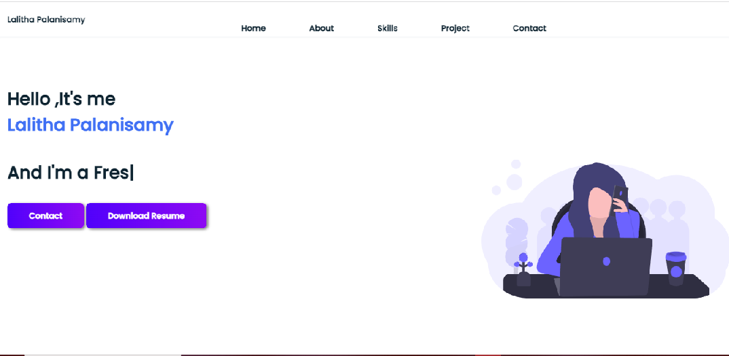

Figure 3.1.1

Description:

The above figure 3.1.1 are the screenshot of Homepage in a desktop view. In this home Screen of the portfolio which shows the landing page and navigation bar. Which shown as figure 3.1.1.

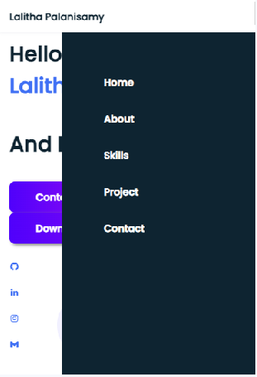

Figure 3.1.2

Description:

The above figure 3.1.2 are the screenshot of Homepage in a mobile view

And this is a home Screen of the portfolio which shows landing page and navigation bar. Which shown as figure 3.1.2

Source Code:

HTML:

<!--HOME SECTION-->

            <section class="home bd_grid" id="home">

                <div class="home_data" data-aos="fade-down">

                    <h1 class="home_title"> Hello ,It's me<br><span class="home_title-color"> Lalitha Palanisamy</span>

                    </h1>

                    <h3>And I'm a <span class="text"></span></h3>

                    <a href="#contact me" class="button">Contact</a>

                    <a href="../portfolio project/Lalitha Resume.pdf" download="My resume" class="button" >Download Resume</a>

                 </div>

                <div class="home_social">

                <a href="https://github.com/LalithaMSccs" target="_blank" class="home_social-icon" data-aos="fade-down"><i class='bx bxl-github'></i></a>

                <a href="http://www.linkedin.com/in/lalitha-palanisamy" target="_blank" class="home_social-icon" data-aos="fade-down" data-aos-delay="250"><i class='bx bxl-linkedin'></i></a>

                <a href="https://www.instagram.com/magic_lily0303" target="_blank"  class="home_social-icon" data-aos="fade-down" data-aos-delay="300"><i class='bx bxl-instagram' ></i></a>

                <a href="mailto:pgcs.lalitha@gmail.com" target="_blank"  class="home_social-icon" data-aos="fade-down" data-aos-delay="350"><i class='bx bxl-gmail'></i></a>

                </div>

                <div class="home_img" data-aos="fade-down" data-aos-delay="500">

                    <svg id="a154b3ae-224e-4b43-86b8-0ffeb27982c5" data-name="Layer 1" xmlns="http://www.w3.org/2000/svg"  viewBox="0 0 1144 637”></svg>

                </div>

            </section>

CSS:

/*ABOUT SECTION*/

.about_container{

*row-gap*: 2rem;

*text-align*: center;

}

.about_subtitle{

*margin-bottom*: var(--mb-2);

}

.about_img{

*justify-content*: center;

}

.about_img svg{

*width*: 300px;

*border-radius*: 0.5rem;

}

JAVASCRIPT:

*const* showMenu=(*toggleId*,*navId*)*=>*{

*const* toggle=document.getElementById(*toggleId*);

*const* nav=document.getElementById(*navId*);

    if(toggle && nav){

        toggle.addEventListener('click',()*=>*{

            nav.classList.toggle('show')

        });

    }

}

showMenu("nav_toggle","nav_menu");

//active & remove active

*const* navlink=document.querySelectorAll('.nav_link');

navlink.forEach(*n* *=>* *n*.classList.remove('active'))

*function* linkAction(){

    navlink.forEach(*n* *=>* *n*.classList.remove('active'))

    this.classList.add('active')

*const* navmenu=document.getElementById('nav_menu')

    navmenu.classList.remove('show')

}

navlink.forEach(*n* *=>* *n*.addEventListener('click',linkAction))

//text animation

*var* typed = new Typed(".text",{

    strings: ["Fresher"

    ],

    typeSpeed: 100,

    backSpeed: 100,

    loop: true

});

3.2 Project Page

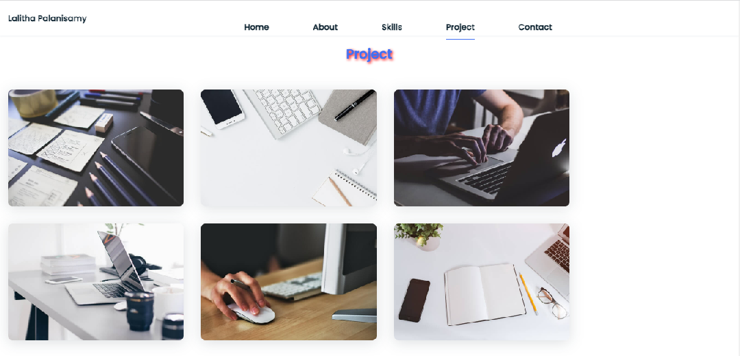

Figure 3.2

Description:

The above figure 3.2 are screenshot of project page in desktop view. In this section, there are 6 project if you click on the image’s it will direct to the project outputs. It will open in another tab and the output of the project will shown.

Source Code:

HTML:

<!--PROJECT SECTION-->

            <section class="project section" id="project">

                <h2 class="section_title" data-aos="fade-down">Project</h2>

                <div class="project_container bd_grid" data-aos="fade-down" data-aos-delay="250">

                    <div class="work_img">

                        <a href="https://lalithamsccs.github.io/ballmove/" target="_blank">

                            <img src="../portfolio project/img/work1.jpg" alt="">

                        </a>

                      </div>

                      <div class="work_img">

                        <a href="https://lalithamsccs.github.io/eyeballmove/" target="_blank">

                            <img src="../portfolio project/img/work2.jpg" alt="">

                        </a>

                    </div>

                      <div class="work_img">

                        <a href="https://lalithamsccs.github.io/pacman/" target="_blank">

                            <img src="../portfolio project/img/work3.jpg" alt="">

                        </a>

                    </div>

                      <div class="work_img">

                        <a href="https://lalithamsccs.github.io/topsalaries/" target="_blank">

                            <img src="../portfolio project/img/work4.jpg" alt="">

                        </a>

                    </div>

                      <div class="work_img">

                        <a href="https://lalithamsccs.github.io/wordcount/" target="_blank">

                            <img src="../portfolio project/img/work5.jpg" alt="">

                        </a>

                    </div>

                      <div class="work_img">

                       <a href="https://lalithamsccs.github.io/balljump/" target="_blank">

                        <img src="../portfolio project/img/work6.jpg" alt="">

                       </a>

                    </div>

                </div>

            </section>

CSS:

/*PROJECT*/

.project{

*text-align*: center;

}

.project_container{

*row-gap*: 2rem;

}

.work_img{

*box-shadow*: 0 4px 25px rgba(14, 36, 49, 0.15);

*border-radius*: 0.5rem;

*overflow*: hidden;

}

.work_img img{

*transition*: 1s;

*cursor*: pointer;

}

.work_img img:hover{

*transform*: scale(1.1);

}

3.3 Skill page

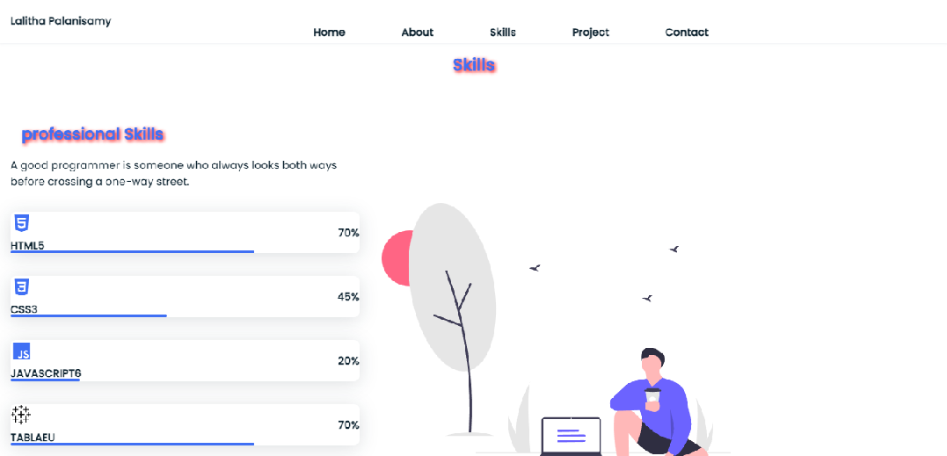

Figure 3.3

Description:

The above figure are skill page, which contains a subdivision Professional Skills . which has my skill levels user can know about my skills and the levels.

Source code:

HTML:

<!--SKILLS SECTION-->

            <section class="skills section" id="skills">

                <h2 class="section_title"  data-aos="fade

-down">Skills</h2>

                <div class="skills_container bd_grid">

                    <div>

                        <h2 class="skills_subtitle" data-aos="fade-down" data-aos-delay="250">professional Skills</h2>

                        <p class="skills_text" data-aos="fade-down" data-aos-delay="350">A good programmer is someone who always looks both ways before crossing a one-way street.

                        </p>

                        <!--SKILLS HTML-->

                        <div class="skills_data"data-aos="fade-right">

                            <div class="skills_name">

                                <i class='bx bxl-html5 skill_icon'></i>

                                <span class="skill_name">HTML5</span>

                            </div>

                            <div><span class="skill_percentage">70%</span></div>

                            <div class="skill_bar skill_html"></div>

                        </div>

                        <!--SKILLS CSS-->

                        <div class="skills_data" data-aos="fade-right" data-aos-delay="250">

                            <div class="skills_name">

                                <i class='bx bxl-css3 skill_icon'></i>

                                <span class="skill_name">CSS3</span>

                            </div>

                            <div><span class="skill_percentage">45%</span></div>

                            <div class="skill_bar skill_css"></div>

                        </div>

                         <!--SKILLS JAVASCRIPT-->

                         <div class="skills_data" data-aos="fade-right" data-aos-delay="250">

                            <div class="skills_name">

                                <i class='bx bxl-javascript skill_icon' ></i>

                                <span class="skill_name">JAVASCRIPT6</span>

                            </div>

                            <div><span class="skill_percentage">20%</span></div>

                            <div class="skill_bar skill_js"></div>

                        </div>

                         <!--SKILLS TABLEAU-->

                         <div class="skills_data" data-aos="fade-right" data-aos-delay="250">

                            <div class="skills_name">

                                <svg  class="skill_icon" width="30px" height="30px" xmlns="http://www.w3.org/2000/svg" viewBox="0 0 512 512"></svg>

                                <span class="skill_name">TABLAEU</span>

                            </div>

                            <div><span class="skill_percentage">70%</span></div>

                            <div class="skill_bar skill_tablaeu"></div>

                        </div>

                        <!--SKILLS EXCEL-->

                        <div class="skills_data" data-aos="fade-right" data-aos-delay="250">

                            <div class="skills_name">

                                <svg  class="skill_icon" xmlns="http://www.w3.org/2000/svg" viewBox="0 0 384 512">svg>

                                <span class="skill_name">EXCEL</span>

                            </div>

                            <div><span class="skill_percentage">60%</span></div>

                            <div class="skill_bar skill_excel"></div>

                        </div>

                        <!--SKILLS PYTHON-->

                        <div class="skills_data" data-aos="fade-right" data-aos-delay="250">

                            <div class="skills_name">

                                <i class='bx bxl-python skill_icon' ></i>

                                <span class="skill_name">PYTHON</span>

                            </div>

                            <div><span class="skill_percentage">40%</span></div>

                            <div class="skill_bar skill_python"></div>

                        </div>

                    </div>

                    <div data-aos="fade-left" data-aos-delay="350">

                        <svg id="a379d9a4-f6fe-40d1-beba-a0916853bd02" data-name="Layer 1" xmlns="http://www.w3.org/2000/svg"  viewBox="0 0 938.75919 806.74836"></svg>

                    </div>

                </div>

            </section>

CSS:

/*SKILLS*/

.skills_container{

*row-gap*: 2rem;

*text-align*: center;

}

.skills_subtitle{

*margin*: var(--mb-2);

}

.skills_text{

*margin-bottom*: var(--mb-4);

}

.skills_data{

*display*: flex;

*justify-content*: space-between;

*align-items*: center;

*position*: relative;

*font-weight*: var(--font-semi);

*padding*: o.5rem 1rem;

*margin-bottom*: var(--mb-4);

*border-radius*: 0.5rem;

*box-shadow*: 0 4px 25px rgba(14, 36, 49, 0.15);

}

.skill_icon{

*font-size*: 2rem;

*margin-right*: var(--mb-2);

*color*: var(--first-color);

}

.skill_name{

*display*: flex;

*align-items*: center;

}

.skill_bar{

*position*: absolute;

*left*: 0;

*bottom*: 0;

*background-color*: var(--first-color);

*height*: 0.25rem;

*border-radius*: 0.5rem;

*z-index*: var(--z-back);

}

.skill_html{

*width*: 70%;

}

.skill_css{

*width*: 45%;

}

.skill_js{

*width*: 20%;

}

.skill_tablaeu{

*width*: 70%;

}

**CHAPTER 4**

STYLES SCORE

4.1 Font Link

/*google font-poppins*/

@import url('https://fonts.googleapis.com/css2?family=Poppins:wght@500&display=swap');

/*variables*/

:root{

    --header-height:3rem;

    --font-semi:600;

}

/*colors*/

:root{

    --first-color:#4070f4;

    --second-color:#0e2431;

    --gradient-color:linear-gradient(to right,#5001fb,#8e0af3);

}

/*font style*/

:root{

    --body-font:'Poppins', sans-serif;

    --big-font-size:2rem;

    --h2-font-size:1.5rem;

    --normal-font-size:0.938rem;

}

4.2 Style links

 <link rel="stylesheet" href="../portfolio project/css/style.css">

        <link rel="stylesheet" href="https://unpkg.com/boxicons@latest/css/boxicons.min.css">

        <link href="https://unpkg.com/aos@2.3.1/dist/aos.css" rel="stylesheet">

        <script src="https://unpkg.com/typed.js@2.0.16/dist/typed.umd.js"></script>

4.3 Use of Grid Layout



Source Code:

HTML:

<!--PROJECT SECTION-->

            <section class="project section" id="project">

                <h2 class="section_title" data-aos="fade-down">Project</h2>

                <div class="project_container bd_grid" data-aos="fade-down" data-aos-delay="250">

                    <div class="work_img">

                        <a href="https://lalithamsccs.github.io/ballmove/" target="_blank">

                            <img src="../portfolio project/img/work1.jpg" alt="">

                        </a>

                      </div>

                      <div class="work_img">

                        <a href="https://lalithamsccs.github.io/eyeballmove/" target="_blank">

                            <img src="../portfolio project/img/work2.jpg" alt="">

                        </a>

                      </div>

                      <div class="work_img">

                        <a href="https://lalithamsccs.github.io/pacman/" target="_blank">

                            <img src="../portfolio project/img/work3.jpg" alt="">

                        </a>

                      </div>

                      <div class="work_img">

                        <a href="https://lalithamsccs.github.io/topsalaries/" target="_blank">

                            <img src="../portfolio project/img/work4.jpg" alt="">

                        </a>

                      </div>

                      <div class="work_img">

                        <a href="https://lalithamsccs.github.io/wordcount/" target="_blank">

                            <img src="../portfolio project/img/work5.jpg" alt="">

                        </a>

                      </div>

                      <div class="work_img">

                       <a href="https://lalithamsccs.github.io/balljump/" target="_blank">

                        <img src="../portfolio project/img/work6.jpg" alt="">

                       </a>

                    </div>

                </div>

            </section>

CSS:

/*PROJECT*/

.project{

*text-align*: center;

}

.project_container{

*row-gap*: 2rem;

}

.work_img{

*box-shadow*: 0 4px 25px rgba(14, 36, 49, 0.15);

*border-radius*: 0.5rem;

*overflow*: hidden;

}

.work_img img{

*transition*: 1s;

*cursor*: pointer;

}

.work_img img:hover{

*transform*: scale(1.1);}

**CHAPTER 5**

Website include the following Information

5.1 Project link to GitHub

# **Project-1**

**Title:** SIMULATION BALL MOVEMENT

**Link:** <https://lalithamsccs.github.io/ballmove/>

#### Poject Description:

This project has a simple green color ball, which will move from top to bottom and bottom to top, like bouncing from between the x and y axis. It will repeat this process whenever we load the page. The ball is created by HTML, CSS. And making the ball to do some event by JAVASCRIPT

# **Project-2**

**Title:** GRAPHIC ANIMATION OF THE RANDOM WALK

**Link:** <https://lalithamsccs.github.io/balljump/>

#### Project Description:

This was a graphic animation of the random ball using plain JavaScript. Drawing in HTML Canvas, also plain CSS is used. The balls will bounce randomly within the box.

# **Project-3**

**Title:** PACMAN MOVEMENT

**Link:** <https://lalithamsccs.github.io/pacman/>

#### Project Description:

In Simulation scheduler a Pac-man in made to move is fixed direction and with a fixed velocity. It will move from the one place of the browser to the end of the screen.

# **Project-4**

**Title**: BOSTON CITY DATA

**Link:** <https://lalithamsccs.github.io/topsalaries/>

#### Project Description:

The walk Boston shows the top five earning employees and the details of the employees by JAVASCRIPT. So through this we can identify and filter the top values from the n number of data’s.

# **Project-5**

**Title**: WORD COUNT

**Link:** <https://lalithamsccs.github.io/wordcount/>

#### Project Description:

In this exercise, we can count the words that how many time it take place in the paragraph. And also it will display the top 3 repeated words.

# **Project-6**

**Title**: EYEBALL MOVE

**Link:** <https://lalithamsccs.github.io/eyeballmove/>

#### Project Description:

In this exercise, we create eyeball using CSS and add JavaScript to move the eyeball. It move’s when curser move.

**CHAPTER 7**

Project README (Description, steps to run, future improvement)

##### **PROJECT 1**

Simulation ball movement

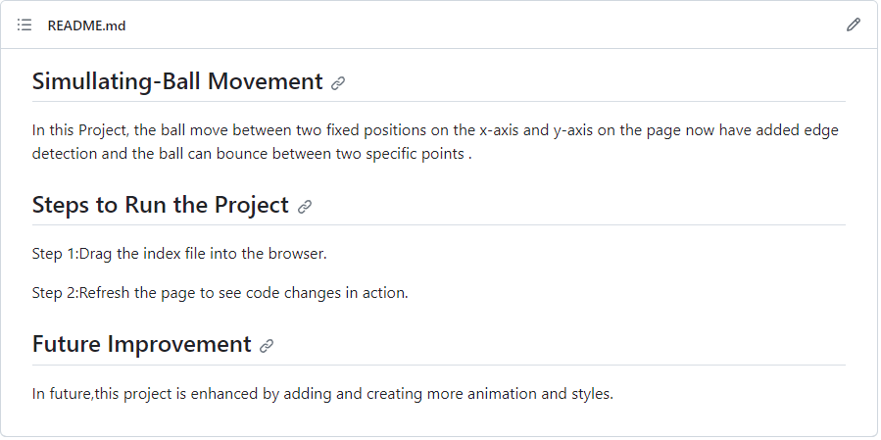

Figure 7.1

##### **PROJECT 2**

Graphics Animation Of Random Walk

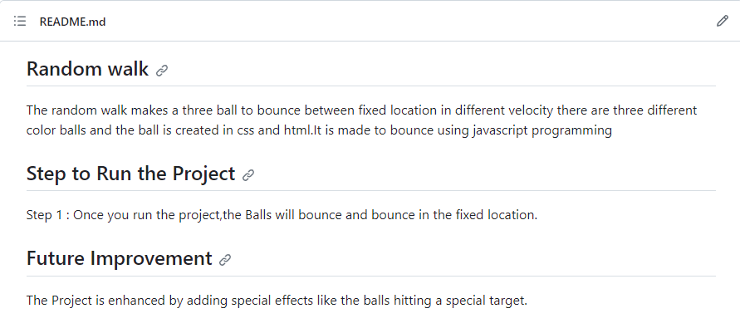

Figure 7.2

##### **PROJECT 3**

PacMan

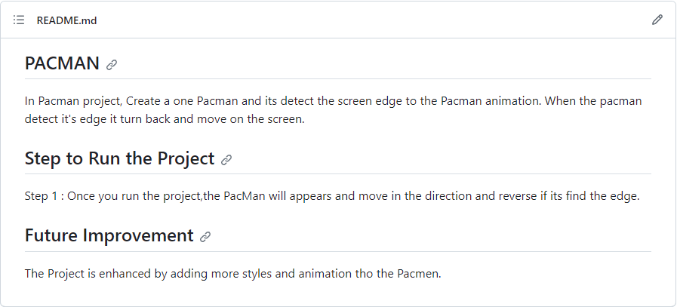

Figure 7.3

##### **PROJECT 4**

Boston city Data

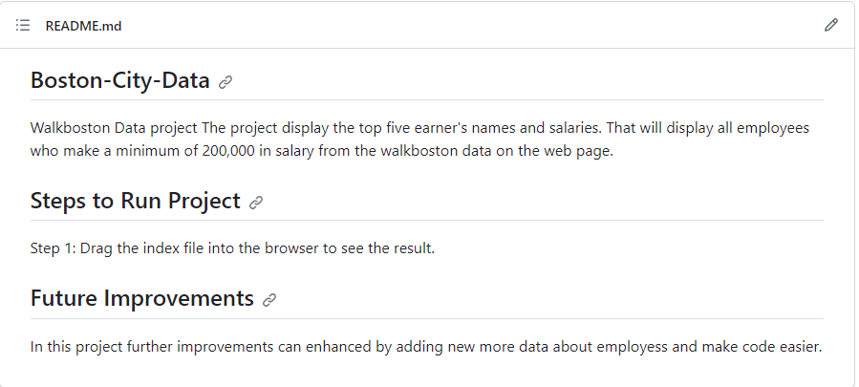

Figure 7.4

##### **PROJECT 5**

Word Count

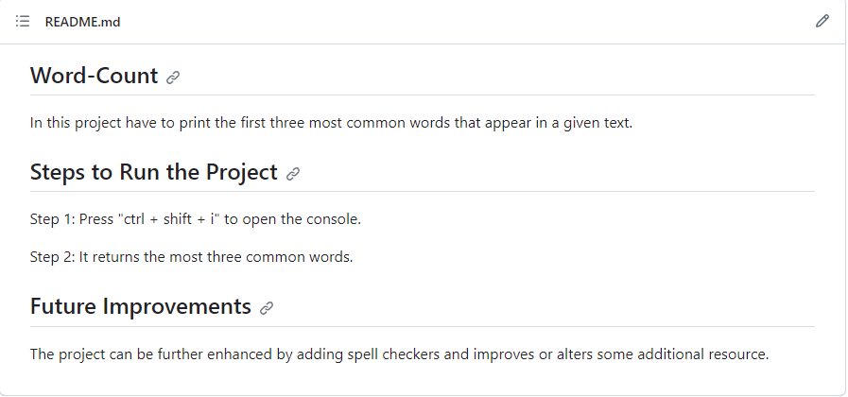

Figure 7.5

##### **PROJECT 6**

Eyeball Move

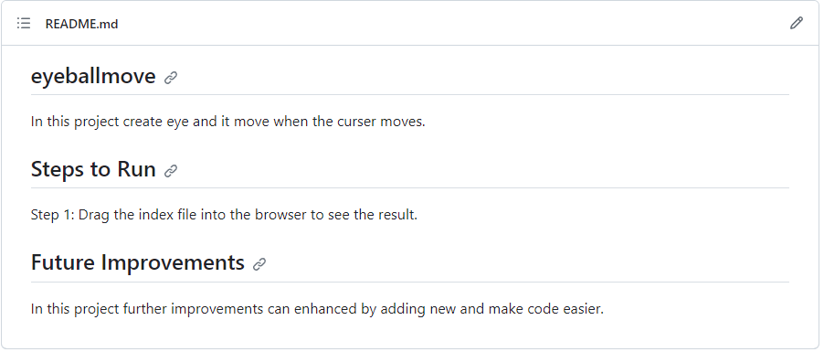

Figure 7.6

### Description:

The above figure 7.1,7.2,7.3,7.4,7.5,7.6, are the screenshot of project README files (Description, steps to run, future improvement) in a desktop view.

**CHAPTER 8**

### File structure

8.1 GitHub file structure Task-1 file structure:

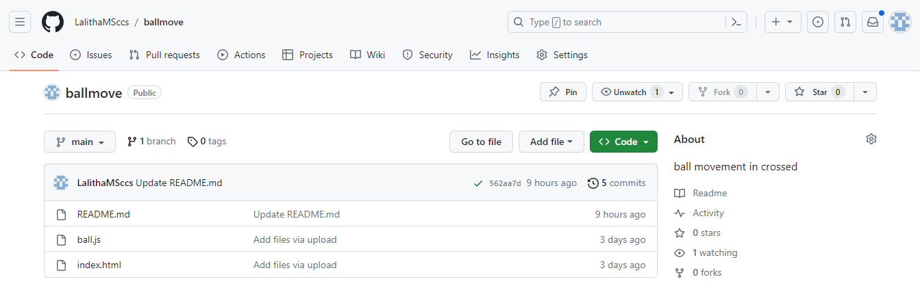

Figure 8.1

Task-2 file structure:

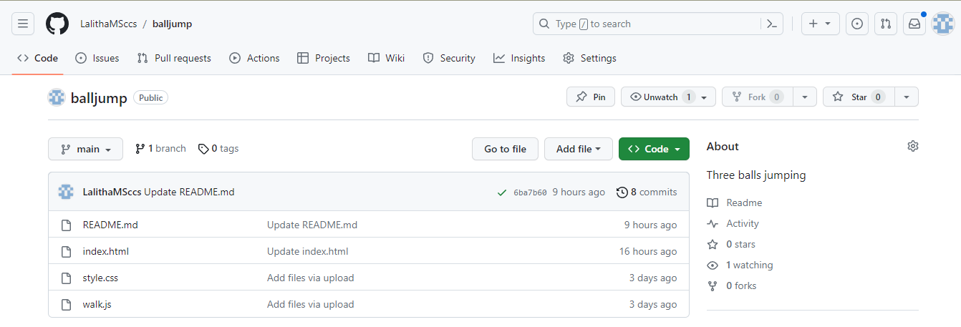

Figure 8.2

Task-3 file structure:

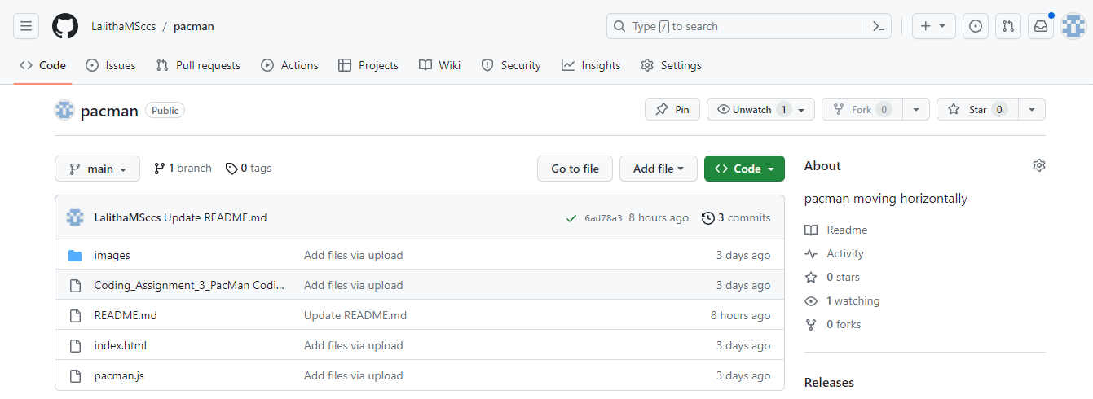

Figure 8.3

Task-4 file structure:

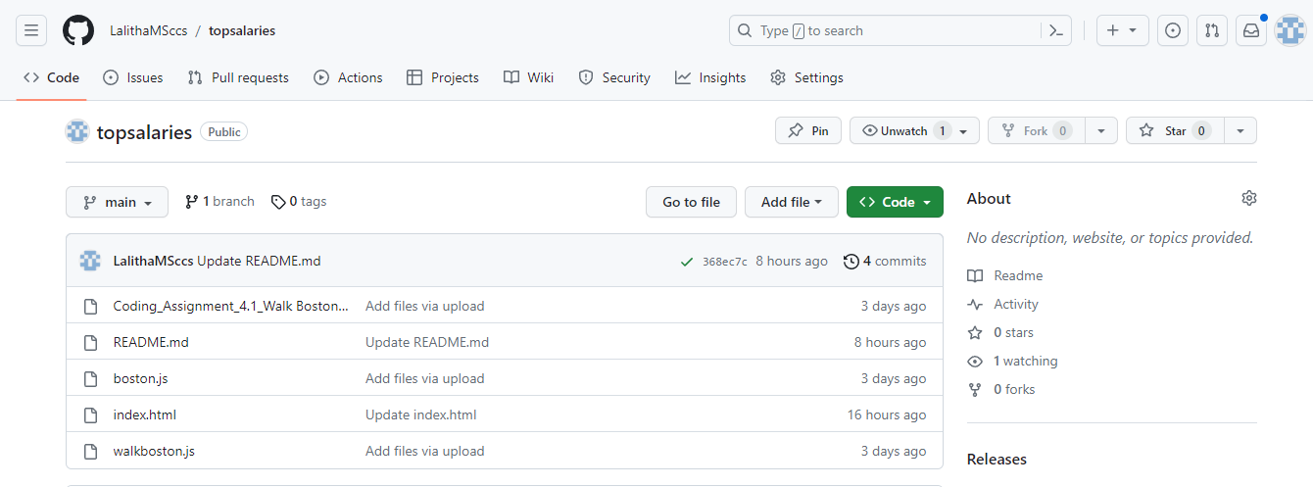

Figure 8.4

Task-5 file structure:

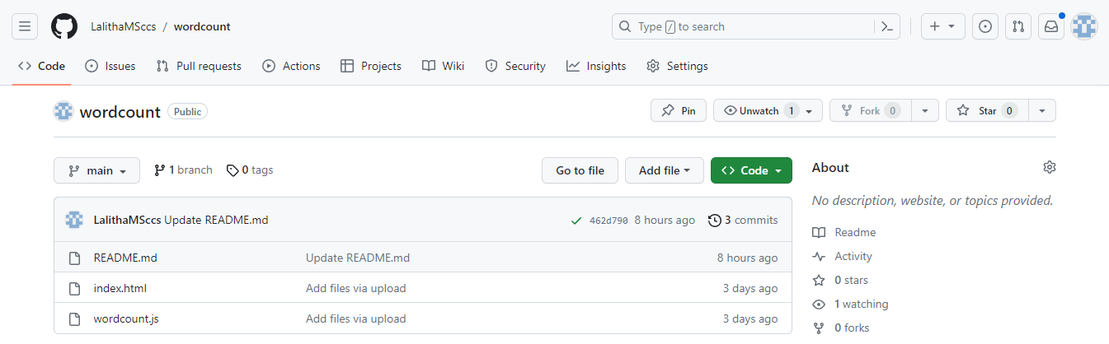

Figure 8.5

Task-6 file structure:

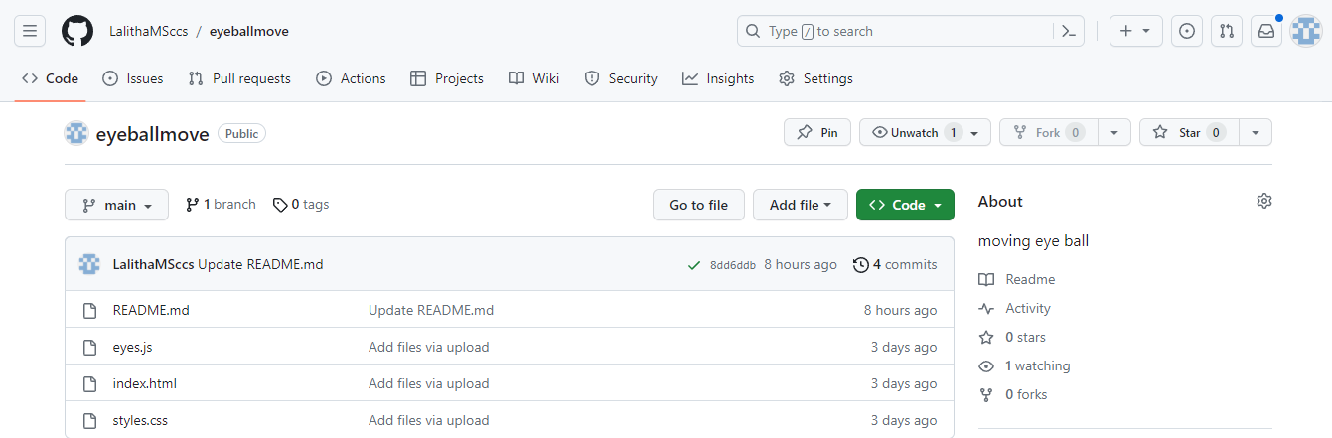

Figure 8.6

### Description:

The above figure 8.1,8.2,8.3,8.4,8.5,8.6, are the screenshot of project GitHub file structure in a desktop view.